**QUESTION:-**

**Use reduce side join to join the two datasets and find What kind of problems are prevalent, and in which state?**

**ANSWER:-**

**Driver class:-**

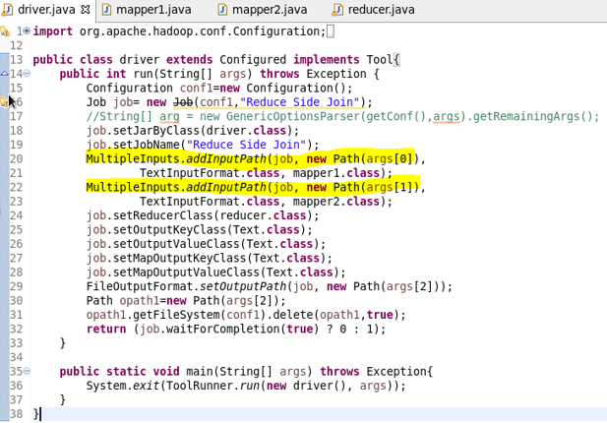

**Mapper1 class:-**

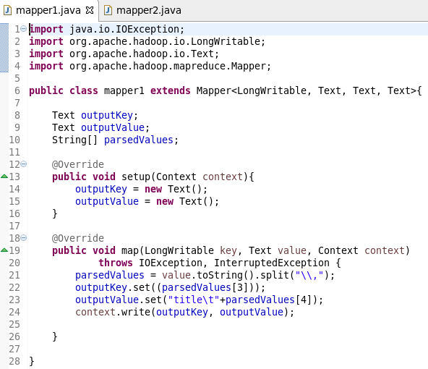

**Mapper2 class:-**

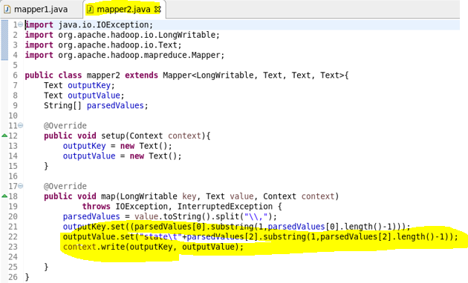

**Reducer class:-**

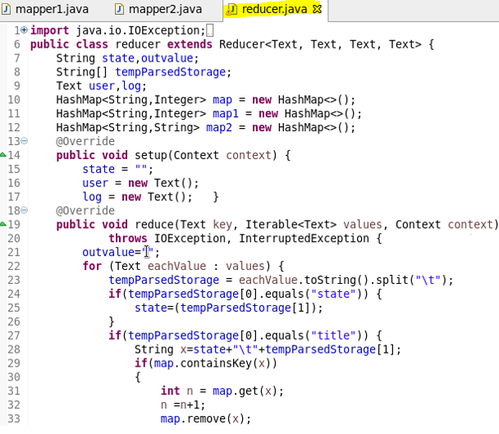

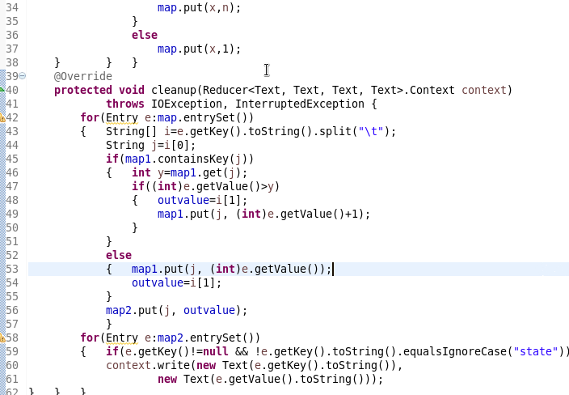

**Running jar:-**

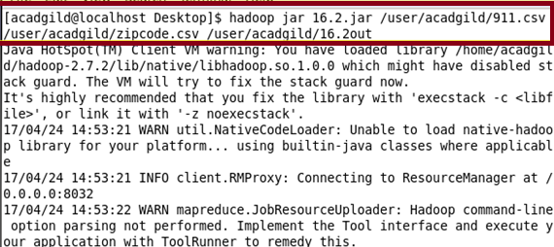

**Output:-**

